Enniskillen Royal Grammar School
ICT Department
Year 10


Pupil Name: _______________
Form Class: _______________
Teacher Name: _______________

Introduction to Game Development

Electronic games played on devices including:

- Game consoles
- Mobile Phones
- Computers
Gaming has developed from the installation of discs on games consoles and playing alone to now using cloud and online multiplayer games.
Educational gaming applications allow users to apply their knowledge and support their learning within a virtual world.
Features such as leader boards help motivate individuals to improve their scores
Can take on different roles within the game and reflect on what happened in certain situations, enhancing learning
Games are designed with rules and increasing levels of difficulty – the user must comply with the rules and cannot move to the next level before completing the previous.

Q. What makes a good game?

History of Gaming
The history of video games goes as far back as the early 1950s, when academic computer scientists began designing simple games and simulations as part of their research or just for fun. At M.I.T. in the 1960s, professors and students played games such as 3D tic-tac-toe and Moon Landing.

These games were played on computer such as the IBM 1560, and moves were made by means of punch cards. Video gaming did not reach mainstream popularity until the 1970s and 1980s, when video arcade games and gaming consoles using joysticks, buttons, and other controllers, along with graphics on computer screens and home computer games were introduced to the general public.

The First Game
TASK
Using the internet, research the first video game created. Complete the following profile page for this game. You can stick images into this profile page also.

It is important to include:
- When it was created
- Who created it
- Why it was created (be careful!)
- How did players interact with it?
- How did you win the game?
Include other key information such as the story behind the game and also how this created a multibillion pound industry.

TASK: Profile Page: The First Game
Game Maker 8 Features
Game Maker 8 is a 2D game engine which allows us to design, build (and play!) a 2D game.
GameMaker is primarily intended for making games with 2D graphics, allowing out-of-box use of bitmap graphics. The engine allows us to use drag and drop options, meaning that a game will not need to be programmed in the way that we can still develop a game without needing to develop the code behind these drag and drop features.

The Game Maker software splits its game creation into several areas/categories in which we can use:
- Sprites

A sprite is an image, or a number of images, that represents something in the game. If a sprite is not animated (a tree in an RPG for example), it only has one image. If it is animated, the sprite has a number of sub-images.
Many games use multiple sprites with different animations each to represent one character performing different actions such as walking, jumping and falling.


Sprite:

- Objects and Instances
You need to first define objects and add them to the resource tree. An object can contain a number of different Events and in each event you can use drag and drop events to define behaviours for that object.

However, this object is not placed into the game, but rather acts as a template for instances which are placed into rooms. An instance is basically a copy of the object that is placed in the room of your game and so, in this way, you would create one wall object and then place 100 instances of it into the room to create your game world.

Object:

Instance:

- Rooms
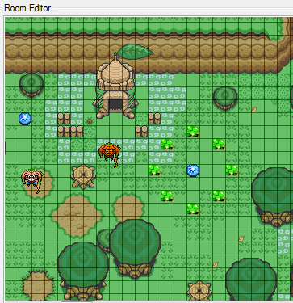
A room in Game Maker is important to include in every game. This is the area we use to add in objects. Not only should you have a room for each level, but you should also have a room for the opening screen, help pages and any credits/end screens you will have.
You must have at least one room in any game for it to run, but in general you will need many more.
The room will be a design of what the player will see when they play a game. It is important that we create these to be very atheistically pleasing to ensure players are interesting in playing your game.

- Sound
Sound, or commonly known as audio, is an important part of creating an engaging game that keeps players interested in the gameplay and mechanics of a game.
We can play sound clips as part of the background music, or even when you lose a life or collect a collectable such as a coin. These add different environments and can alter the mood of the game very quickly. For example, a scream could be used to darken the mood whilst a hand-clap could be used when you complete a level. These ultimately impact how we as gamers know if we are successfully playing the game.
- Backgrounds
Much like sound, the background can drastically change the mood or feeling of a game. Using dark backgrounds can make a game seem scary or using a light background could make the game a lot more child-friendly in its approach to gaming. It is important that the background reflects the genre of the game, as mis-matching elements can mean that the game becomes clunky and unsuitable for its target audience.

Genres Available in Game Making

A genre identifies the style or category of a piece of work, like a book, poem or film. Games also fall into different genres.

Genre:

Games are not usually defined by the actual content of the games, but rather by the challenges, story and gameplay that are contained within the game.

There are loads of popular game genres available to users, each with their own characteristics and challenges within the game itself. There are loads of genres available, some of which we will be discussing below.
Action
Action games emphasize physical challenges that require Hand-eye coordination and motor skill to overcome. They centre around the player, who is in control of most of the action. Most of the earliest video games were considered action games; today, it is still a vast genre covering all games that involve physical challenges.
Action games are classified by many subgenres. Platform games and fighting games are among the best-known subgenres, while shooter games became and continue to be one of the dominant genres in video gaming since the 1990s.
Adventure
Unlike adventure films, adventure games are not defined by story or content. Rather, adventure describes a manner of gameplay without reflex challenges or action. They normally require the player to solve various puzzles by interacting with people or the environment, most often in a non-confrontational way. It is considered a "purist" genre and tends to exclude anything which includes action elements beyond a mini game.
Role Playing
Most of these games cast the player in the role of one or more "adventurers" who specialize in specific skill sets (such as melee combat or casting magic spells) while progressing through a predetermined storyline. Many involve manoeuvring these character(s) through an over world, usually populated with monsters, that allows access to more important game locations, such as towns, dungeons, and castles.
Simulation
Simulation video games is a diverse super-category of games, generally designed to closely simulate aspects of a real or fictional reality.
Strategy
Strategy video games focus on gameplay requiring careful and skilful thinking and planning in order to achieve victory and the action scales from world domination to squad-based tactics.
Sports
Sports are video games that simulate sports. This opposing team(s) can be controlled by other real-life people or artificial intelligence.

TASK
Pick two different genres from the above list and research them. Produce an A4 poster describing both, with examples of real games or popular games as examples. Describe how the games fall into the genre(s).

List the game information below:
 | Game 1 | Game 2
Genre
Details

Include details on genre, age rating, storyline, target audience, developer information, scoring system and aim of the game in your description!

Gaming Platforms

How do we play games?
What do we use?
Where are we?
Hardware/Software?

Q. What Platforms are available to you to play games?

Typically, we use gaming consoles, such as Play Stations and Xboxes as the platform to play many games. The games that we play may be purchases and played online, for a monthly subscription or purchased in store and inserted into the game console.
Mobile gaming is becoming more and more popular, with games available for purchase and download through the app stores for mobile phones or tablets. Many of these games are played in the same kind of way, navigating through levels to collect credit and ultimately win at the end. However, a newer and less common technology is immerging, and their popularity is increasing rapidly.
These technologies are called VR and AR.

VR
VR stands for Virtual Reality. It’s a world that doesn’t exist. This virtual reality has been created by a computer, which allows users to experience and interact with a 3D world, using a VR headset. This headset allows the user to view a 360 image of a world that a computer has generated. Additional technologies can be incorporated to add sound and movement.
The most well-known example of VR is Minecraft. Minecraft allows users to build a variety of different blocks in a 3D procedurally generated world, using the players’ creativity. It is the second most best-selling PC game, with around 29 million copies sold. (Minecraft logo)

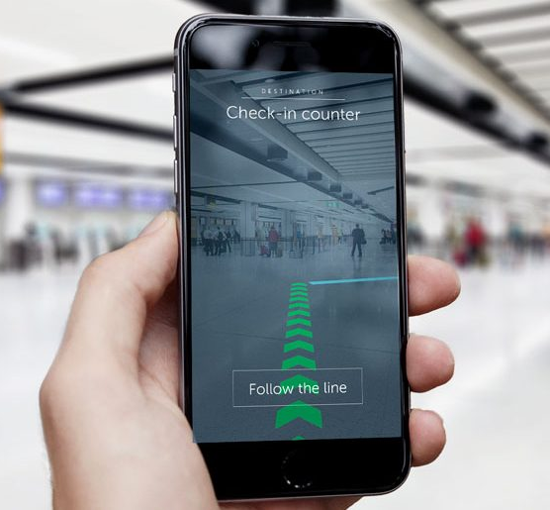
AR
AR stands for Augmented Reality. This means adding computer generated images into real life. For example, some furniture shops have an app or additional functionality on their websites, which allow users to view pieces of furniture in their own rooms. This incorporated the use of device cameras and their internet connection. (Pokemon Go)
Pokemon Go is a mobile game, which was designed for use on Android and iOS devises in 2016. This game uses mobile devices GPS to locate, capture, battle and train virtual creatures, which appear as if they are in the player’s real life location. By the end of 2016, it was downloaded more than 500 million times worldwide. In addition to using a new technology called AR, it also encouraged physical activity, and some businesses credited it for increasing profit due to increased foot traffic.

Scoring and its Importance in Gaming
Scoring refers to an abstract quantity associated with a player or team. Score is usually measured in the abstract unit of points, and events in the game can raise or lower the score of different parties.
Most games with score use it as a quantitative indicator of success in the game, and in competitive games, a goal is often made of attaining a better score than one's opponents in order to win.
Scoring is very different from game to game, as it can be seen as a way to ‘win’ the game. However, game developers have implemented this differently in different games. For example, in Fortnite or Apex Legends there is no ‘High Score’ table, but instead uses a ‘last man standing’ approach.
Other games implement scores differently, and some games include no score at all! Solitaire, a card game, is a perfect example of this where no score is implemented at all – and yet can still be classed as a game as you can still ‘win’.

Your Target Audience
The ‘target audience’ can be defined as a particular group at which a product such as a film or advertisement is aimed.
When developing a game, it is very important to keep the target audience in mind as it will ultimately be those players who will be playing your game. A game such as Fortnite will be aimed a majority young teens, yet a game like Chess will be aimed at logical thinkers and a more mature generation of gamer.
TASK
Look at the images below and decide what would the target audience be. Explain why this is the case.
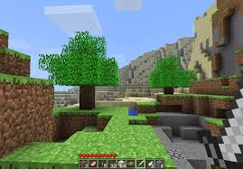 | 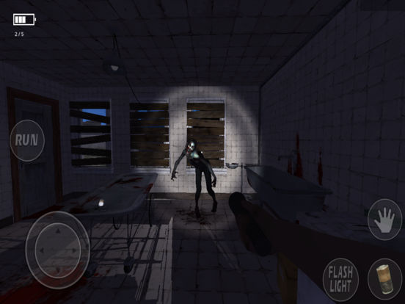
The Task
Magic Amusements are an up and coming Game Development company, situated in Belfast. They specialise in 3D games, however are wishing to expand their company by developing a 2D game aimed at teenagers aged 10-14.

The aim is to create an engaging first product which will allow the user to:
- View an introductory Title Screen, which includes a company logo and information of how to access the main menu
- A Main menu, which allows the user to:
  - Start the Game
  - Access A help feature
  - View Highscore
  - Load the previously saved game
  - View Credits of the Game
- At least three levels, each of which get slightly harder. All levels should be possible to complete
- A Scoring system
- Collectables
The Game should be developed using the Game Maker software, and should have a continuous theme throughout. The title of the Game has been left to you to decide, but should be suitable to the target audience.

Storyboarding
Within your game, you will be required to storyboard your:
- Front/Opening Page | Your loading Screen | The Different Levels | The final/End Credits Screen | Help Page
Use the space below to design these Screens. You will need to label the different colours, fonts and layouts for each screen.
Opening Screen: | Loading Screen: | Level 1
Level 2 | End Credits Screen | Help Page

